Yorkshire Sport Foundation

Board Meeting Minutes
Date: Monday 17 July 2023
Venue: The Hut, Airedale, Wakefield
Board Members: Paul Reid (Chair), Caroline Black, Jim Lord, John Williams, Gwen Smith, Helen Gauden, Brendan Fatchett, Rashida Salloo
Apologies: Sarah Muckle, Ben Smith
Supporting Officers: Nigel Harrison, Gemma Armitage, James Brown, Dan Wilson, Lisa Moseley, Julian Pratt, Andy Morgan
Guests: Sarah Loader, Francesca Stanyer (online)

Minutes
Agenda Item | Action
- Welcome and Apologies
Paul welcomed everyone to the meeting, he introduced individuals who have not attended the meeting previously.
- Board Matters
2.1 Declarations of Interest
None
- Minutes of Previous Meeting
The group were happy with the contents of the minutes.
Matters arising;
Nigel updated on the outstanding actions. Research is still on-going to find a suitable safeguarding for the Board that is not too onerous.
- Community development work in Airedale
Nigel introduced Lisa, a Community Development Manager who works in the Airedale area. Lisa shared some of the challenges of working in Airedale. Despite having some good assets in the area these are not being used to their full potential due to several factors including the wrong positioning, opening hours that are not suitable and the culture of the community around the facility. She described some successful sessions that took place but are unable to continue due to lack of funding. The work in the area has been very challenging and requires different solutions with no one size fits all approach. Lisa confirmed for the group that there is potential for change in the area however it will take time. The work has provided a lot of learning that YSF are able to use in the future.
Paul asked if there was data to back up a reduction in anti-social behaviour whilst the sessions were running. This would give some good evidence to take forward to future funding applications.
The group discussed further challenges including the possibility of adding younger representation on the Board. The group thanked Lisa for her contribution and insight.
- Communication Plan and Measurement
Nigel introduced Julian and Andy who presented to the Board the different audiences served by YSF and the Communication Plan. The group asked what the time split of work looks like between the groups. Andy confirmed that mostly they focused on Internal and Partners with the Executive group and Media being less. A discussion also took place around benchmarking of other similar organisations so performance can be understood in relation to those organisations. The group commented that the measures included are much better and report the communication functions work in a much rounder way. This all adds to the strong and trusted brand vision pillar.
The group discussed the potential ramifications of negative publicity on Board Members, Andy confirmed the crisis comms plan would be followed in this eventuality.
- Board Governance and Training Plan  Paul took the group through the effectiveness report and thanked them for their time and contributions towards it. He also suggested to the Board that once the changes have been made after the AGM the group take stock and re-evaluate the trustee mix. Caroline noted that there were a couple of possibilities of new board members that are still to be followed up from the Chair recruitment process.  Nigel set out the proposed plan as follows;  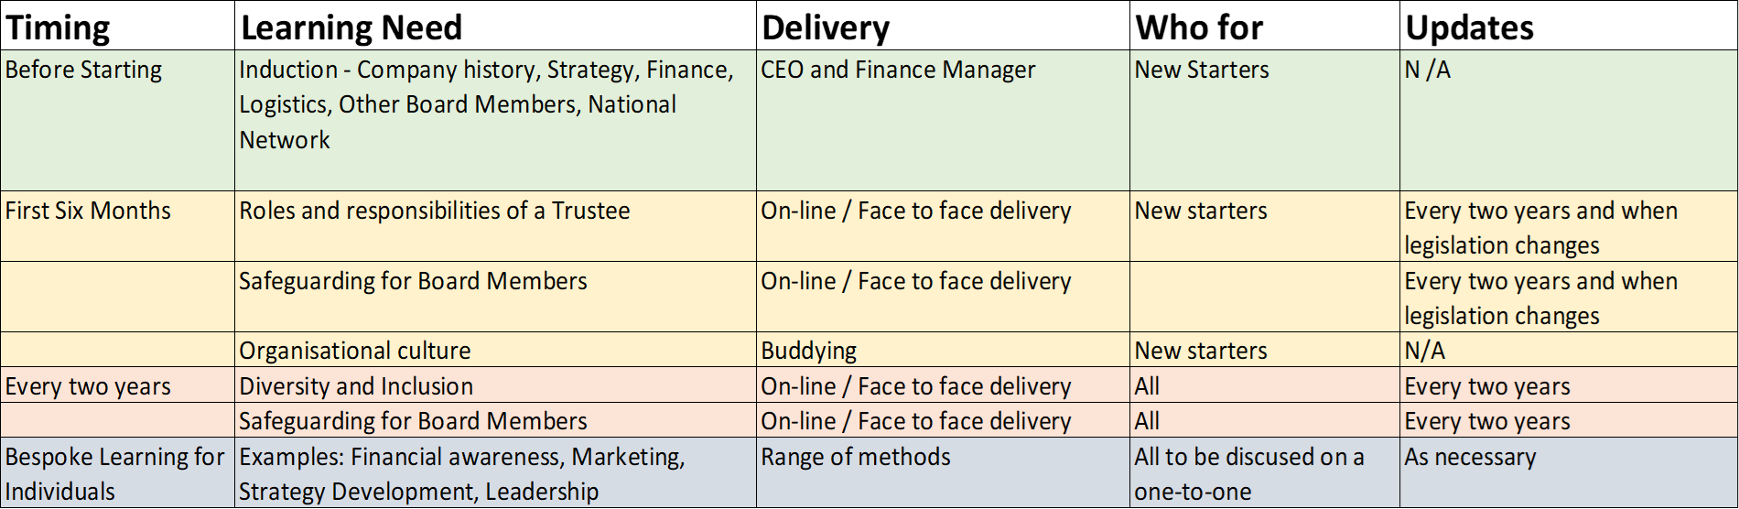The group agreed that the following items were missing;  - Media Training – basic and crisis  - 1:1s with other Trustees  - Regular recap of legal duties  - Diversity and Inclusion training may need to be more often due to how dynamic the topic is  Action: to add horizon scanning of YSF obligations to the Finance, Audit and Risk Committee standing agenda. | GA
- Directors Update  Nigel highlighted the moving forward of the Placed Based Partnerships and the influencing role both YSF and the wider Active Partnerships are having being at the forefront of discussions.  Paul asked if there were anything we could do to help Kirklees as they don’t currently have a portfolio holder with a sport remit due to lack of resource and staffing changes. Nigel confirmed that we are supporting where we can with a potential temporary solution identified to fill the gap.  A few points of clarification were requested;  - 4.3, what is the Doncaster Skills Board – CIMSPA (Chartered Institute for the Management of Sport and Physical Activity) have provided funding to set up skills board in place to put action plans in place to increase skills in the area.  - 4.2, how will we retain, recruit and reward targeted volunteers – this is not for our volunteers but we are writing the strategy for the West Riding County FA’s volunteers.  - 4.1, Opening School Facilities, where are we with this programme – we have hit the required targets allowing us to really deep dive into our focus areas including pupil referral units and special schools. The biggest obstacle the schools have been facing is the capacity to both apply and carry out the contract. We are helping schools through that.  - 4.4, it was requested that the new marketing pack be circulated. Dan confirmed that some of the opportunities have been given to us whereas others are due to the greater focus from the Income Generation group and the freeing up of Dan’s time.  Action: Share the new marketing pack with the group. | GA
- Performance Report
Paul suggested Brendan take on the sponsor of the first vision pillar. He also questioned the green rating of the £250,000 additional funding as less than £50,000 has been received therefore is it under what would be expected at this point in the year. Helen confirmed that there is funding in the pipeline and we are confident of hitting the target.
Paul commented that the journey on the performance report is the biggest change within his eight years on the Board. The report is much easier to understand and interact with. James also commented that Sport England have been interested in the journey and are taking a lot of learning from us. Paul added that the leadership we provide in the sector is huge and we should keep pushing that.
The group discussed the three stars awarded by Best Companies and noted it is an incredible result.
Helen queried if we were able to rate the code as a green as the results of the review had not get been received, the group discussed and were happy with the rating. She also commented that Health and Safety rating feels a little light and may benefit from an increase in emphasis, this was noted.
- Finance, Audit and Risk Committee
Helen comments that the FAR Committee reviewed the Q1 finance report and were happy with the current position. The group are keeping an eye on the admin target which has fluctuated as described in the report. She confirmed that this no longer has to be reported back to Sport England however is a good measure to keep an eye on. Paul commented that the financial governance is very good.
Helen updated the group on the Risk Register and they were happy on the updates provided.
- HR, and Health and Safety
The group discussed the Best Companies rating of world class and congratulated everyone on their work to achieve the rating. Caroline commented that a 9% increase in the “my manager” category is difficult to achieve and shows a really good culture within the organisation. The group asked what the next steps are. Nigel confirmed that the data would be shared with the team at an Away Day where the team can reflect on the outcome and the opportunities it brings.
Paul felt the reward and recognition the accolade brings shows how connected the organisation is throughout all levels. He commented that the job evaluation that took place earlier in the year may have cost a little bit of money but that is being paid back in spades. It shows the Trustees are able to create the right space for the team to thrive.
Paul also commented that the sickness rates look really good and are a good indication of happy staff.
- Any other urgent business
None

- Board reflections on the meeting
The group agreed it was a good meeting with appropriate challenge. They also commented that the Board Pack provided was good which allowed an effective meeting.

Agenda Item | Action | Lead | When | Update
Actions from matters arising
3 | - Book safeguarding training for Board Members | NH | ASAP
Actions from July meeting
6 | - To add horizon scanning of YSF obligations to the Finance, Audit and Risk Committee standing agenda. | GA | Next FAR meeting
7 | - Share the new marketing pack with the group. | GA | ASAP

