Sustainable sport and physical activity work stream explanatory account

**Key:**

Green = new statements with supporting evidence

Amber = no/mixed evidence

Red = contrary evidence (remove in next iteration if no supporting evidence)

**Purple** = example iterative changes based on learning

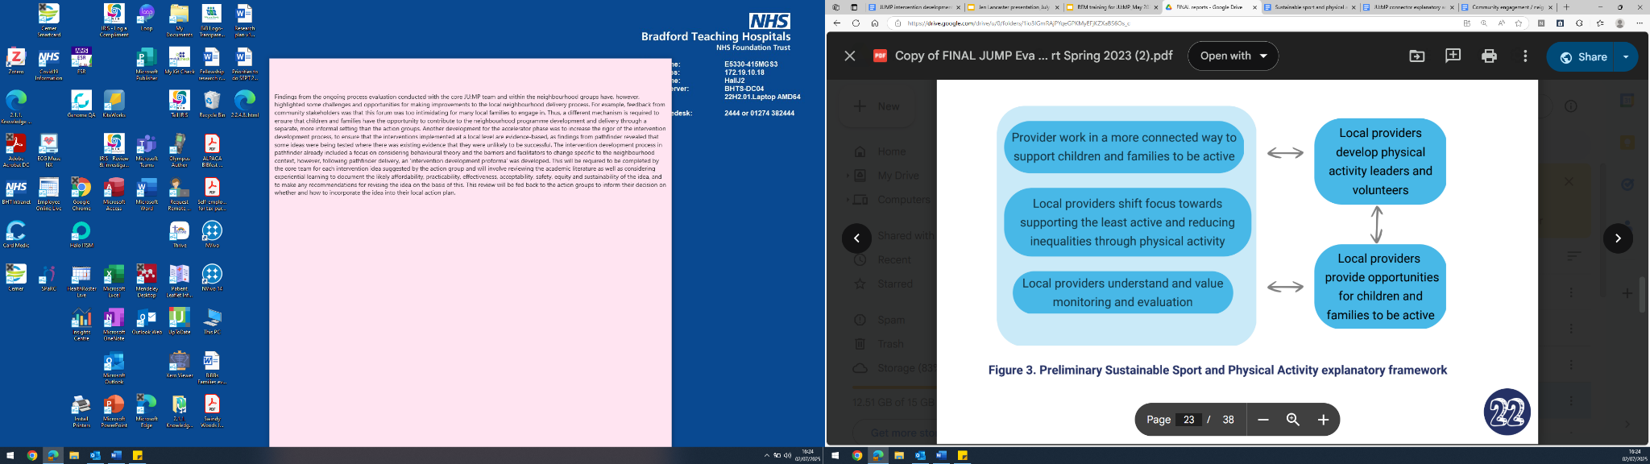

**SECTOR INTEGRATION OF PA**

**“Local providers and organisations work in a more coordinated and connected way to support C&YP to be active”**

* Community of learning (CoL) events (I-C) facilitate more joined up working amongst providers (O) as facilitated discussions help to make providers more aware of each other and what they can offer to and benefit from others (M)
* Increased time allocation to structured connection activities at events (I-C) to permit longer conversations and conversations with a wider range of stakeholders (M), and incorporating unstructured networking time into community of learning events (I-C), increases connectivity and collaboration between providers and organisations (O) - time to this increased moving forwards
* Providing CoL attendees with a resource that includes details of other organisations and on which they can record discussions and actions (I-C), increases connectivity and collaboration between providers and organisations (O) as providers are more aware of others’ roles and have a tangible reminder (M)
* Frequency of CoL events (i.e. 6-monthly) and CoL events in isolation (I-C) are not sufficient to foster meaningful and timely collaborations (O) - digital comms trialled
* An open and live ‘list’ of stakeholders, including their role and contact details, what they can offer to others and what their needs are (I-C) would facilitate collaboration (O)
* The JU:MP ‘brand’ (I-C) facilitates relationship building with other organisations (O)
* The hyper-local neighbourhood approach (I-C) acts as a barrier to sustainable sport providers developing connections across various areas (O), as it favours regular meeting of hyper-local stakeholders rather than cross-sectoral networking across the patch (M)
* Working in a more joined up way with other providers increases session attendance
* Knowing when others are delivering sessions increases attendance through promoting others’ sessions and/or putting sessions on at different times - developed ‘what's on’ mechanism for providers to sign up to
* Working in partnership with primary schools (I-C) can be financially beneficial for providers (M) which may lead to more sustainable provision in the long-term (O)
* The ‘opening school facilities’ national programme and the nature of ‘academy’ schools (C) help foster collaboration between sport and PA providers and schools (O)

**STRENGTHENING COMMUNITY AND INDIVIDUAL CAPACITIES**

**“Local providers and organisations shift focus towards supporting the least active and reducing inequalities through physical activity”**

* JU:MP funding allows local providers/organisations to develop physical activity provision for the least active (removed due to lack of specificity)
* Incorporating evidence surrounding health inequalities and the importance of targeting the least active into tenders, service level agreements and contract management meetings (I-C) encourages providers to target the least active (O)
* JU:MP funding/support (I-C) leads to changes at an organisational level including adaptations to wider organisational practices such as recruiting and training more female volunteers, and offering activities focused on participation rather than competition, with the ambition of reaching the least active (O)

**“Local providers, organisations and JU:MP connectors develop young people / parents / volunteers to lead physical activity within their local community”**

* Developing volunteers (I-C) facilitates increased local provision (O) as there are more staff available to support session delivery (M) - specify in tenders a focus on developing volunteers as part of delivery
* Developing volunteers (I-C) facilitates sustainability of session delivery (O) as volunteers may continue to run sessions independently (M)
* Gradual engagement of parent volunteers (I-C) attracts people into volunteering who may have said no if asked more directly or given more responsibility from the start (O)
* Regular ‘meet-ups’ for volunteers (I-C) provides recognition and social support to volunteers (M) which works to retain them (O)
* Capacity building through training (I-C) attracts people into volunteering (M), and can build skills, knowledge and confidence (M) to deliver sessions safely and effectively (O)
* This is restricted by current JU:MP oversight/ processes including organisations only being able to have one ‘active’ training fund application © - increased this to two
* Volunteer capacity building through training and delivery experience (I-C) increases employability (O), through being more likely to meet essential requirements of jobs (M)
* Volunteer capacity building (I-C) increases employability (M) which may reduce sustainability of organised sessions (O) and/or increase the financial and social support these parents are able to provide to their children to be active (O)
* Young people/parent volunteers (I-C) engage local young people in physical activity (O) as they are seen as role models who show it is possible for ‘people like us’ to be active and succeed in dance/certain sports (M)
* Providing training to volunteers (I-C) increases families’ engagement with sessions (O), as it provides reassurance to parents regarding safety (M)
* Local volunteers (I-C) increase engagement of local families and their attendance at organised sessions (O) through knowing more people locally that they can persuade to come (M), and being trusted by families *because* they are known to them (M)

**“Local providers and organisations (including JU:MP connectors) understand and value monitoring and evaluation”**

* Monitoring and evaluation training and support from JU:MP (I-C) upskills providers and helps them see the value of this activity (O)
* Lack of acceptability of the monitoring *process* detracts fromany change in attitude towards monitoring in general © - adapted process to be less onerous
* Increased skill/motivation related to monitoring and evaluation increases engagement in monitoring activity and reflective practice, which enhances ongoing delivery
* Lack of acceptability of the monitoring *process* restricts any increased engagement in monitoring activity © - adapted process to be less onerous
* JU:MP monitoring requirements (I-C) restrict providers’ and JU:MP connectors’ direct engagement with children and families and provision of opportunities for children and families to be active (O) because the monitoring, in particular recording individual attendances and collating this from different session leads, requires significant time input which directly detracts from the time available to deliver (M) -adapted process to be less onerous

**TACKLING STRUCTURAL INEQUALITIES**

**“Local providers and organisations provide opportunities for children and families to be active”**

* Offering sessions at no cost (I-C) is essential to engaging the most deprived and least active (O), in the context of the cost of living crisis and when working in deprived areas (C) as the most deprived families prioritise spending money on essentials (M) - no longer require providers to test a ‘small charge’ model
* Providers putting on sessions (I-C) directly increases local opportunities for children and families to be active (M), which increases attendance at organised activity sessions (O)
* When sessions are delivered at, and in partnership with more established community organisations (C), sessions are better attended (O) as the organisations have strong existing relationships with local children and families (M)
* Group-based physical activity delivery in isolation (I-C) does not lead to behaviour change in families beyond session attendance (O)
* Presence of female delivery staff (I-C) can change attitudes regarding whether certain sports are ‘for girls’ (M) which can increase activity beyond sessions - increased focus on developing female leaders
* Demonstration (I-C) leading to increased skills in, for example, riding a bike and bike repairs (M) can increase activity beyond sessions