Club Anti-Racism Policy Template

This template can be used as a starting point to make an anti-racism policy that represents the aims of your club, members, staff and your place in the local community. 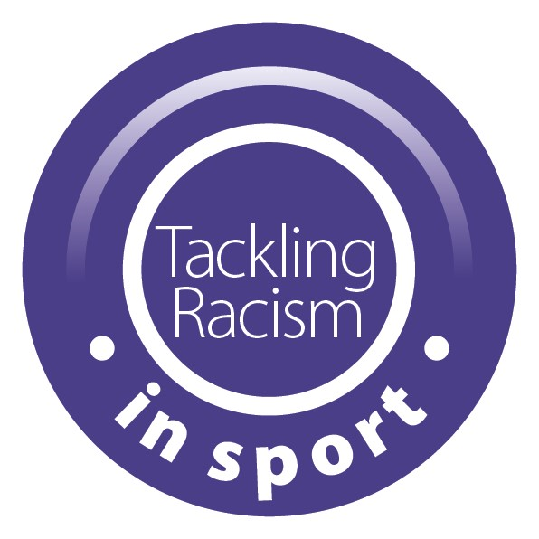

This anti-racism policy is designed to sit within a wider inclusion policy which addresses other challenges around equality and diversity. This policy shows we share the Yorkshire and Humber Anti-Racism in Sport Group’s ‘Commitment to tackling racism and racial inequality in community sport in Yorkshire and the Humber.’

Our aim is that this will help Yorkshire and the Humber be the kindest, friendliest and most inclusive place to take part in sport.

How to use this template:

1. Complete the highlighted areas
2. Delete this top section
3. Upload to your website and let people know where to find it.
4. Review at the date indicated

========================================================================

**Anti-Racism Policy for (Club Name)**

**Introduction**

Our Diversity and Inclusion statement: At (Club Name), we are committed to fostering an inclusive and respectful environment for all individuals associated with the club including members, participants, coaches, officials, staff, and supporters. We firmly believe in promoting diversity, equity, and social justice. Our aim is to provide an environment where everyone feels:

* Welcome
* Represented
* Included in decision making
* Able to participate
* Safe and free from discrimination, bullying, harassment and vilification.

This Anti-Racism Policy outlines our dedication to eradicating racism from our club and the steps we take to ensure a safe and welcoming atmosphere for everyone involved.

**Commitment**

* We unequivocally condemn all forms of racism, discrimination, and harassment.
* We commit to maintaining a zero-tolerance stance towards any behaviours, actions, or language that perpetuate racism.
* We will ensure that every member of (Club Name) is treated fairly and equally, regardless of their race, ethnicity, nationality, colour, religion, or background.
* All individuals will have equal opportunities to participate, compete, and contribute to the club's activities.
* We will create a welcoming club environment for all.
* We will consider how our club/group is promoted. For example, by providing information in formats which are accessible and by using appropriate imagery.
* We will provide ongoing education and training programs for athletes, coaches, staff, and volunteers to increase awareness and understanding of racism, its impact, and how to prevent it.

**Reporting and Handling Incidents**

* Any incidents of racial discrimination or harassment should be reported to club officials who will then inform the designated welfare lead immediately.
* We will establish clear and confidential channels for reporting incidents of racism or discriminatory behaviour. This will be promoted throughout the club.
* All reports of racism will be thoroughly and impartially investigated.
* The club will take appropriate action against individuals found responsible for such behaviour, which may include disciplinary measures such as suspension or expulsion. Behaviour that might breach the law could be reported to the relevant authorities.
* Advice and referral from necessary governing bodies and support organisations will take place where appropriate.
* We are committed to supporting individuals who experience racism within our club. We will support them through the investigation process and any actions taken.

**Review**

This policy will be reviewed (recommended annually) in line with club policy to ensure its effectiveness and relevance to our commitment to tackling racism and racial inequality.

We believe that by implementing this policy, we contribute to a fairer, more inclusive sport community that stands against racism and embraces racial equality.

Feedback from club members and stakeholders will be sought to improve the policy’s implementation.

By adhering to this Anti-Racism Policy, (Club Name) is committed to creating a safe, diverse, and inclusive environment for all involved in the club.

Signed:

Club role:

Date:

Review date:

**Club information**

Designated officer:

Reporting details (phone number, email address, web page):

------------------------------------------------------------------------------------------------------------------------

This policy was produced with support by the Yorkshire and Humber Anti-Racism in Sport Group’s Commitment to tackling racism and racial inequality in community sport