|  |
| --- |
| Sense Logo with tagline |

**Leading Hazel off the side-lines and onto the ski slopes**

### **‘Complex Disabilities in Sport’ workshop launched to provide more active opportunities for people like Hazel, living with complex disabilities**

Embargoed until 9am on 29 April 2024

[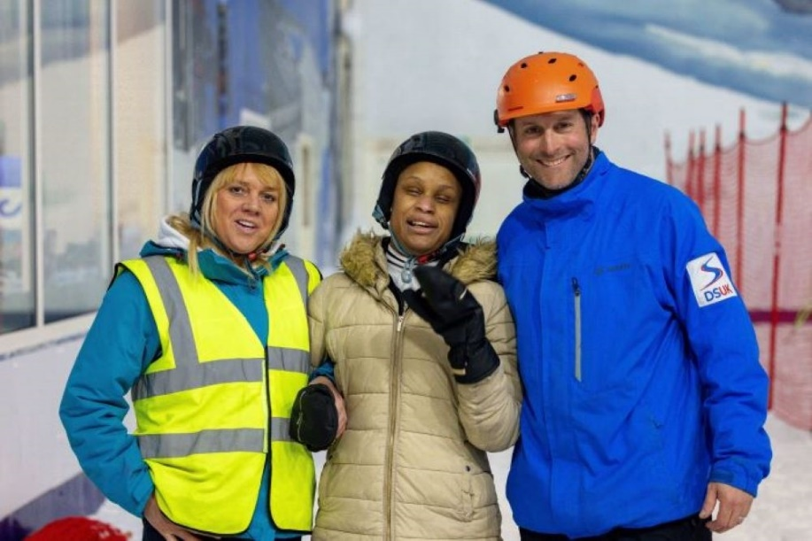](http://www.sense.org.uk/hazels-ski-story)

Image description: Two women, Tracey and Hazel, and a man, James, stand arm-in-arm at an indoor ski centre. They’re wearing thick coats and helmets and are smiling to camera.

Photography: Cameron Ross Hall // Holmlands

Hazel, who is blind and living with complex disabilities, absolutely loves skiing and the feeling of a “sensory explosion”. With the right support, [Sense Active](http://www.sense.org.uk/sense-active) and [Disability Snowsport UK](https://www.disabilitysnowsport.org.uk/) have provided an opportunity for Hazel to build confidence in her own abilities and connect with people.

The joy on Hazel’s face, the giggles on the last run, it proves that snow sports can be accessible for all.

Tracey, who supports Hazel at Sense, said:

“Just because she can’t see it, doesn’t mean she can’t feel it. Skiing and things like this are good for Hazel, she’s blind and lives with complex disabilities, she can sometimes feel a bit isolated from everybody else. There’s nothing worse than feeling left out.

By taking part in the snow sports activities, it has given Hazel the confidence that she can take into other aspects of her life.”

## Learn how to provide meaningful activities for people with complex disabilities

Sense is dedicated to empowering people with complex disabilities to lead active and healthy lives. Because no one should be left on the side-lines.

If you've been inspired by Hazel's story and want support people with complex disabilities to be active, sign up to their new ‘Complex Disabilities in Sport’ workshop.

The three-hour workshop includes practical and theory-based guidance on how to:

1. Develop a meaningful approach to making sport accessible.
2. Achieve effective communication and engagement with your participants.
3. Prepare, deliver and evaluate inclusive sport activities.

**Sign up to the new Sense Active** [**‘Complex Disabilities in Sport’ workshop**](http://www.sense.org.uk/complex-disabilities-in-sport-workshop).

Callan Barber, Active Lifestyles Workforce Manager at Sense, said:

“It is crucial that we empower sports coaches and instructors, regardless of the sport or activity, helping them gain the tools they need to create life-changing experiences for people like Hazel.

Our new workshop will leave providers feeling confident and motivated to plan and deliver person-centred opportunities to everyone with complex disabilities.”

For more information, visit [**sense.org.uk/complex-disabilities-in-sport-workshop**](http://www.sense.org.uk/complex-disabilities-in-sport-workshop)or email [**callan.barber@sense.org.uk**](mailto:callan.barber@sense.org.uk)**.**

--

About Sense

Sense is a national disability charity that supports people living with complex disabilities, including those who are deafblind, to communicate and experience the world.

Sense supports children, young people and adults in their home and in the community, in their education and transition to adulthood and through its holidays, arts, sports and wellbeing programmes. In addition to practical support to families, Sense also offers information advice, short breaks and family events, and campaigns for the rights of people with complex disabilities to take part in life.

For more information, please visit [**sense.org.uk**](http://www.sense.org.uk)**.**